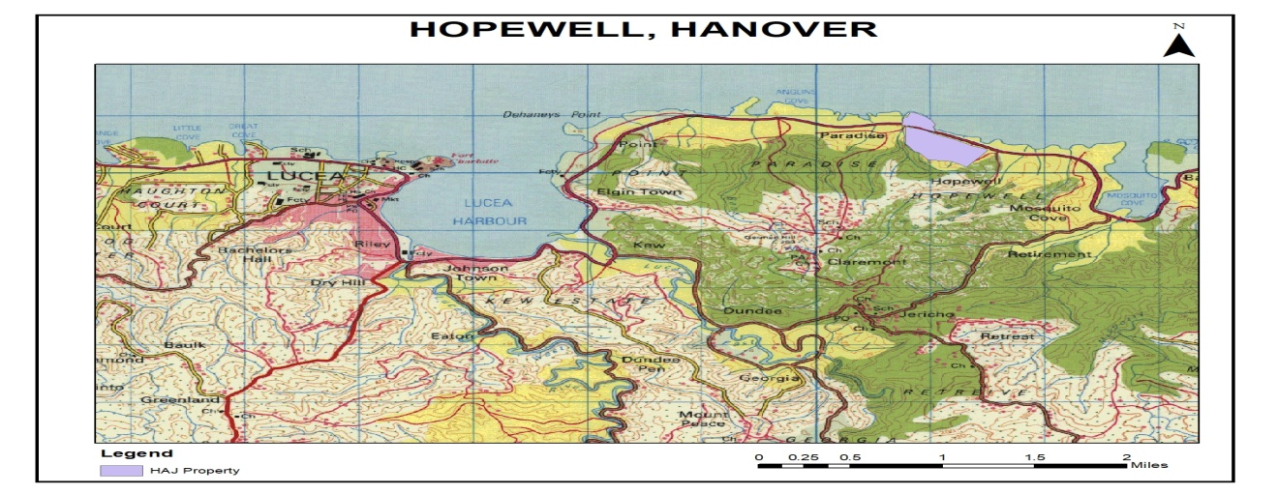
Sale of Prime Investment Properties, West Point Vistas, Hopewell, Hanover

Request for Proposal

Released: 30th July 2023
Deadline for Clarification: Friday, August 11, 2023
Deadline for Proposals: Friday, August 18, 2023

13 Caledonia Avenue
Kingston 5
Table of Contents
OVERVIEW 4
BACKGROUND AND GENERAL INFORMATION OF THE PROPOSED SITE 5
GENERAL TERMS AND CONDITIONS 8
REQUESTS FOR CLARIFICATION 8
CONTACTING HOUSING AGENCY OF JAMAICA 8
SITE VISIT(S) 9
GUARANTEE DEPOSIT 9
SUBMISSION OF PROPOSALS 10
VALIDITY OF PROPOSALS 11
DEADLINE FOR SUBMISSION OF PROPOSALS 11
LATE PROPOSALS 11
COST OF SUBMITTING PROPOSAL 11
MODIFICATION AND WITHDRAWAL OF PROPOSALS 11
OPENING OF PROPOSALS 12
EXPECTED DATE OF CONTRACT 12
CONFLICT OF INTEREST 12
DECLARATION 13
DISCLAIMER 14
PREPARATION OF THE PROPOSAL 16
ORAL PRESENTATION 17
EVALUATION OF PROPOSALS 17
SELECTION CRITERIA 17
EVALUATION CRITERIA 17
CONTRACT NEGOTIATIONS 18
BIDDING FORM 1 - MONETARY OFFER SUBMISSION FORM 19
BIDDING FORM 2 – GUARANTEE DEPOSIT FORM (BID BOND) 20
BIDDING FORM 3A - PARTNERSHIP STATEMENT 22
BIDDING FORM 3B - CORPORATION STATEMENT 23
BIDDING FORM 3C - JOINT VENTURE STATEMENT 24
BIDDING FORM 4 - FINANCIAL DISCLOSURE FORM 25
BIDDING FORM 5 - DISCLOSURE AND CERTIFICATION FORM 26
BIDDING FORM 6 – DECLARATION OF CONFLICT OF INTEREST 27
APPENDIX 1 – CERTIFICATES OF TITLE 29

OVERVIEW
Housing Agency of Jamaica Limited (HAJL), is a wholly owned public sector entity charged with the mandate of providing viable and affordable housing solutions, including the regularization of informal communities. The Agency has within its portfolio of real estate assets, properties at Hopewell in the parish of Hanover more suited for resort, commercial and or high income residential development.

HAJL therefore invites proposals from interested parties for the acquisition of two parcels of land being sold to one buyer:

(1) 5.1927 Hectares (12.82 Acres) of Beachfront Property registered at Volume 1454 Folio 893, and
(2) 135 Hectares (334.8 Acres) contained in two contiguous parcels, registered at Volume 1467 Folio 249 and Volume 1446 Folio 993

This is an opportunity to be part of the thriving real estate market along the Negril to Montego Bay corridor. The successful bidder has the opportunity to realize substantial financial return and will facilitate local job creation as well as spur economic growth and development in the area.

The Request for Proposal (RFP) is intended to guide the prospective investor on the basis upon which the submitted proposal will be evaluated and accepted. Details of the Invitation and the requirements of prospective investor are contained in the body of this document.

BACKGROUND AND GENERAL INFORMATION OF THE PROPOSED SITE

Two (2) separate properties are being divested by way of sale by HAJL:
Property 1:
A small beachfront parcel of approximately 5.2 hectares registered at Volume 1454 Folio 893. It has hugh potential for tourism related business and is situated on the northern side of the Montego Bay to Lucea main road, adjacent to the Dolphin Cove attraction.
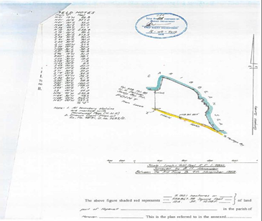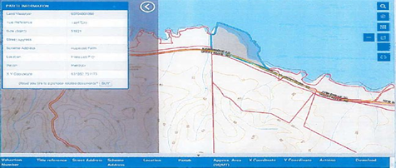

The site is asymmetrical in shape, relatively flat and enjoys a road frontage of approximately 265 metres. The property’s location is surrounded by prime resort destinations along the north coast: shopping, banking and other cultural, social and economical activities within the nearby town centers of Lucea and Montego Bay. Its physical characteristics include a tranquil atmosphere, beaches and main road frontages, a picturesque view of the Caribbean Sea as well as availability of utilities and services.

PROPERTY 2:
This is a much larger property consisting of 135 Hectares and is contained in two Certificates of Title, Volume 1467 Folio 249 and Volume 1446 Folio 993. This property is separated from the Beachfront parcel by the Montego Bay to Lucea Main Road and is in close proximity to the Grand Palladium Jamaica Resort. . The property extends inland and is undulating, with a series of elevated hillocks and valleys. The majority of the property is covered in natural forest and has a panoramic view of the Caribbean Sea and its environs.
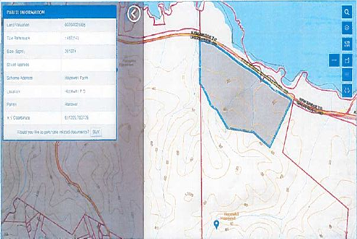
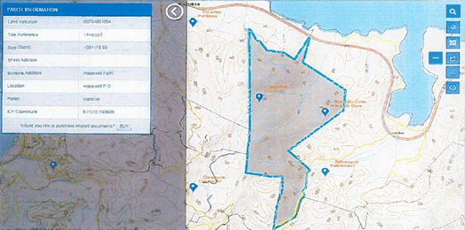

The locale is known as Hopewell Farms and forms part of a series of large properties along the Sandy Bay to Lucea leg of the Northern Coastal Highway, commencing at Blue Hole, immediately west of Sandy Bay, traversing Mosquito Cove, Barbican, Hopewell Farm onto Point. The area is zoned for residential/agricultural land uses however it is being utilized by other investors for resort development. The Property has access to: paved roadways, water supply, electricity, telephones, internet, postal services, police protection, shopping, garbage collection, entertainment, hotels and attractions.

GENERAL TERMS AND CONDITIONS

The objective of this Request for Proposal is to select an investor to whom the HAJL will sell as part of its Divestment Programme the parcels of lots stated herein. While price is a significant factor, other criteria will form the basis of award decision, as more fully described in the Evaluation Criteria section of this Request for Proposal. The HAJL therefore reserves the right not to accept the highest or any bid submitted.

REQUESTS FOR CLARIFICATION

If any bidder is in doubt as to the meaning or interpretation of any part of the RFP, should seek clarification in writing from the Procurement Unit, Housing Agency Of Jamaica Limited, 13 Caledonia Avenue, Kingston 5, Jamaica or via email at procurement@hajl.gov.jm.
Clarifications should be submitted on or before Friday, August 11, 2023 at 4:00 p.m., that is, one (1) week prior to the deadline for submission. The HAJL will respond to the Enquirer in the manner in which the request was made and will send copies of the request and clarification to all prospective bidders without identifying the source of the request. All emails should be directed to procurement@hajl.gov.jm.
Should HAJL deem it necessary to amend this RFP as a result of any clarification sought or received, this shall be done by issuing an Addendum forwarded in hard copy or by email, to all bidders and same Addendum shall be read as one with the RFP originally issued.
HAJL may in its sole discretion extend the deadline for the submission of bids to allow Bidders to take account of the amendment(s) in preparing their Proposals.

CONTACTING HOUSING AGENCY OF JAMAICA

Request for Clarifications, and all correspondences relating to this RFP are to be addressed to:

Procurement Unit
Housing Agency of Jamaica
13 Caledonia Avenue
Kingston 5
Telephone: 876-968-7522-4
E-mail: procurement@hajl.gov.jm
Subject: Request for Proposal, Sale of Properties at Hopewell, Hanover.

SITE VISIT(S)

Prospective investors are advised to visit and examine the site to obtain for themselves, all information that may be necessary for preparing the proposal prior to entering into a Sale Agreement. The costs of visiting the site shall be at the bidder's own expense and bidders are advised to undertake inspections within a reasonable time as no extension of the submission deadline will be granted due to a failure to properly inspect the premises. The HAJL will not be responsible for any liability in respect of personal injury, loss of or damage to property, costs and expenses however caused.
HAJL can make itself available to facilitate a site visit of the area on Friday, August 4, 2023 at 12 p.m.
Interested persons should contact Samuel Pinnock at 876-579-8185 or email: procurement@hajl.gov.jm to confirm and arrange same.

GUARANTEE DEPOSIT

Each proposal must be accompanied by a Guarantee Deposit as outlined below:

If the Bidder supplies a | Then it should
Guarantee Deposit | - Be in the form of a Managers Cheque payable to the Housing Agency of Jamaica Limited  - Be in the amount of $5,000,000.00 Jamaican Dollars
Bid Bond in the Format at Appendix 3 | Be in the amount of $5,000,000.00 Jamaican Dollars.

Note: In the event the HAJL cancels the award of the agreement prior to the execution of the Sale Agreement, all Guarantee Deposits will be returned to the Bidder.
Unless applied to the Security Deposit required pursuant to the Sale Agreement, the HAJL will release or return the successful Bidder’s Guarantee Deposit within thirty (30) days after both parties have fully executed the Sale Agreement.

If the successful Bidder | Then the Guarantee Deposit will
Executes and returns the Agreement | Be refunded to the Bidder, or applied to the Security Deposit of the Sale Agreement.
Fails to execute and return the Agreement | Be forfeited to and retained by the HAJL as Liquidated Damages

Guarantee Deposits from unsuccessful Bidder will be returned within thirty (30) days of the execution of the Sale Agreement with the successful Bidder. Should the negotiations be unsuccessful the next ranked Bidder will be invited for negotiation.

SUBMISSION OF PROPOSALS
Proposals are to be submitted either electronically or by hard copy.
Option 1: Hard copy submissions may be packaged in a sealed envelope and marked with the text:
Procurement Unit
Housing Agency of Jamaica Limited
13 Caledonia Avenue
Kingston 5
Re: Request for Proposal, Sale of Properties at Hopewell, Hanover

Sealed and Labelled Proposals should be deposited in the Tender Box labelled “Request for Proposal, Sale of Hopewell Properties, Hanover”, located on the second floor of HAJL’s Head Office, 13 Caledonia Avenue, Kingston 5, by the deadline for the submission of proposals.

Option 2: Electronic copy should be submitted to the following email address on or before the stipulated deadline date:
Email address: procurement@hajl.gov.jm

VALIDITY OF PROPOSALS

Bidders are required to guarantee the validity of their proposals, for a period of one hundred and twenty (120) days from the Date of Submission of Propsal and may be extended by the mutual consent of the Bidder and the HAJL.

DEADLINE FOR SUBMISSION OF PROPOSALS
All Proposals must be properly submitted in accordance with the requirements of this Invitation by 3:00 p.m. on Friday, August 18, 2023. Proposals submitted after the stated date and time will be automatically rejected.

LATE PROPOSALS
Any proposal received by HAJL after the prescribed deadline for the submission of proposals will be NOT be accepted nor will it be considered for evaluation.

COST OF SUBMITTING PROPOSAL
The Bidder shall bear all costs associated with the preparation and submission of its proposal and HAJL will not be responsible or liable for those costs, regardless of the outcome of the selection process. The cost of preparing the Proposal or providing additional information is the sole responsibility of the Bidder(s). HAJL will not pay or reimburse any brokerage fee or other similar fees to any Bidder and/or their Agents.

MODIFICATION AND WITHDRAWAL OF PROPOSALS

The Bidder may modify or withdraw their proposal after submission provided that written notice of the modification or withdrawal is received by HAJL prior to the prescribed deadline for Submission of Proposals. The Bidder’s modification or withdrawal notice shall be prepared, sealed, marked and dispatched as for proposal submission. HAJL reserves the right to reject, in whole or in part, any Proposal for which a modification is submitted after the deadline for the submission of bids.

OPENING OF PROPOSALS

Proposals will be opened at 3:15 p.m. on Friday, August 18, 2023 at the same location for the receipt and opening of proposals.

EXPECTED DATE OF CONTRACT

Conclusion and execution of a contract for the sale of property is subject to the approval of HAJL Board, Portfolio Minister and The Cabinet.
HAJL has established the following tentative completion dates for this RFP:
- Release of this RFP on July 30, 2023
- HAJL facilitated site visit on August 4, 2023 at 12 p.m.
- Request for Clarification submitted on or before Friday, August 11, 2023 at 4:00 p.m.
- Proposals received by HAJL on or before Friday, August 18, 2023 at 3:00 p.m.
- Negotiation, if any, Review and evaluation completed by September 7, 2023 at 3:00 p.m.
- Board Review and approval September, 2023
- Cabinet Approval by October 2023
- Sale Agreement executed by October-November 2023

CONFLICT OF INTEREST

All personnel involved in the divestment process are expected to observe the GOJ Code of Conduct for Civil Servants outlined in the Staff Orders. They are expected to be free from interests or relationships that are actually or potentially detrimental to the best interests of the Government, and shall not engage or participate in any transaction involving a company, its affiliates, divisions or subsidiaries, in which they have even minor interests.

DECLARATION

Any employee involved in the divestment process, who has entered into, or is about to enter into a financial or other business relationship that might involve a conflict of interest, must immediately inform their supervisors in writing of the circumstances involved. This information is to be reviewed at an appropriate level and a decision taken as to whether there is a conflict of interest, and if so, what course of action is to be adopted.

It is the duty of all staff and any other Public Officers and officials directly or indirectly involved in the divestment process - especially in the preparation of bidding documents; evaluation; contract negotiations; contract management; and payments - to declare any potential conflicts of interest. A conflict of interest will arise when the individual has a direct or indirect relationship with a contractor, investor or potential investor which may affect or might reasonably be deemed by others, to affect impartiality on any matter related to his/her duties.

A conflict of interest exists when GOJ employees involved in the divestment process:
- have an outside interest that materially encroaches on time or attention that should be devoted to the affairs of GOJ;
- have a direct or indirect interest in, or relationship with an outsider that is inherently unethical, or who it might be implied or construed could make possible personal gain due to his/her ability to influence dealings or otherwise inhibit the impartiality of the employee’s judgment;
- are directors/owners/shareholders in a company incorporated either locally or overseas, which is bidding on a GOJ contract (this excludes persons holding shares bought on public offer);
- take personal advantage of an opportunity that properly belongs to GOJ;
- use GOJ property without approval; and
- disclose GOJ trade secrets or any other proprietary information to unauthorized persons.

A Public Officer shall declare any relationship with a Bidder, and shall take no part in either the decision-making process or the implementation of any contract where such a relationship exists. A personal relationship is defined as consanguinity or affinity. Disclosure may be made in writing or verbally, in the context of a meeting. However, having made the disclosure, the individual shall not sit in the meeting while deliberations on the issue are being conducted.

DISCLAIMER

This RFP is an invitation to submit proposals and no contractual obligations whatsoever shall arise from this process, unless and until an agreement is expressly concluded between HAJL and the selected Bidder.

HAJL shall not be liable to pay or reimburse any cost incurred or to make compensation for any inconvenience suffered in relation to a response to this RFP. Nothing contained or implied in the RFP, or RFP process, or any other communication by HAJL to any Bidder shall be construed as legal, financial or other advice.

HAJL without further qualification, reserves the right to:
- Disqualify a Bidder in the event that, in the sole discretion of HAJL, their Proposal does not conform to the requirements for this submission, or the Proposal does not contain sufficient information to permit a thorough analysis;
- Verify the validity of the information supplied and to reject any Proposal where, in its estimation, the contents appear to be inaccurate or inadequate;
- Accept Proposals in whole or in part;
- In its sole discretion, cancel this Request for Proposal without award or compensation to bidders, their officers, directors, employees or agents;
- Reject any or all Proposals;
- Accept the Proposal(s) which, in the sole opinion of HAJL is (are) deemed to be the most advantageous to HAJL and Jamaica; and
- Request any other information it requires to evaluate the submissions. Failure to provide the information requested may result in the proposal being disqualified.

The Bidders assume responsibility for complying with all applicable laws and regulations and is responsible for obtaining all permits required by law or local authorities for any development.

PREPARATION OF THE PROPOSAL

All proposals being submitted should provide a clear indication of:
- CONTACT DETAILS: Name, Address and Contact Information of the bidder(s) responding to the proposal Firm/Individual Overview. (Bidding Form 3)
- PROFILE: Provide a brief description of the organisation or individual, year established, company registration, types of business conducted, and particulars of the directors and shareholders of the company. (Bidding Form 3, 3A, 3B, 3C)
- OFFER: A monetary offer for the acquisition of the properties (Monetary Offer Form at Bidding Form 1 must be completed).
- GUARANTEE: A bid guarantee totalling Five Million Jamaican Dollars (J$5,000,000.00) must be submitted to participate in the divestment process in either:
  - Managers Cheque; or
  - Bid Bond (Bidding Form 2)
- FINANCIAL CAPABILITY: Evidence of their ability to finance the acquisition of the property /properties and the proposed development may be either of the following:
  - Bank guarantee covering the full cost of the acquisition;
  - Bank statement, including average balance over two years, confirming adequate ability to finance acquisition;
  - Letter from a registered financial institution confirming that the applicant has equity and ability to obtain financing for acquisition or a financial undertaking accompanied by a two year audited financial statement;

- OTHER: Any other information which the bidder deems advantageous to their application- Bidding Form 4-6

NB: The monetary offer should be for a specific dollar value and NOT an indicative range. The exchange rate that will be applicable for bids submitted in any currency other than the Jamaican Dollar will be converted using the Bank of Jamaica weighted rate at the closing date for submission of proposals.

ORAL PRESENTATION

At the sole discretion of HAJL, bidders may be asked to present their proposals orally and/or provide clarification regarding their proposals. The time, date, and location of these presentations will be determined after the closing date of the Request for Proposals and HAJL’s initial review of proposals.

EVALUATION OF PROPOSALS

SELECTION CRITERIA

Each Proposal will be evaluated and weighted based on the information provided. The Proposal receiving the most points will be the preferred proposal which may be subjected to further independent due diligence and negotiations.

HAJL reserves the right to indicate to the second highest bidder that they will be considered in the event that the successful bidder fails to Contract with the HAJL.

EVALUATION CRITERIA

The minimum score to qualify to be ranked is 70. The total score will be as a result of summing all points and the entity or person with the highest score will be recommended to the HAJL Board. All qualified proposals received will be evaluated based on the following schedule/criteria:
# | Evaluation Criteria | Score
1 | Offer Price as a Percentage of HAJL’s Market Valuation of the Property (Sum offered to HAJL for the property)  Offer Price:  - More than 100% of HAJL’s Market Valuation  - Greater than 90% and less than 100%  - Greater than 75% and less than 90%  - Less than 75% | 30  20  10  5
Maximum Score |  | 30
2 | Value of Total Investment  Calculation: Investment under consideration x 40  Highest proposed investment | 40
Maximum Score |  | 40
3 | Ability to Finance the Acquisition and development of Property  - Bank guarantee/ Credit Line covering the full cost of the acquisition;  - Bank statement from a Registered financial institution in Jamaica, including average balance over two years, confirming adequate ability to finance acquisition;  - Letter from a registered financial institution confirming that the applicant has equity and ability to obtain financing for acquisition or a financial undertaking accompanied by a two year audited financial statement;  - None of the above | 30  25  15  0
Maximum Score |  | 30
Overall Maximum score |  | 100

CONTRACT NEGOTIATIONS

Bidders who are shortlisted will be ranked from the highest to the lowest score and HAJL will choose the highest scoring Bidder to begin negotiations. If HAJL fails to arrive at an agreement with the first ranked bidder the second bidder in the rank will be chosen for negotiations.

A Sale Agreement will be signed with the Bidder upon conclusion of negotiations. It should be noted that if a sale of the subject property is awarded pursuant to this RFP, the successful bidder /purchaser is required to pay the following cost in order to effect sale:
- The sale price (an initial deposit and thereafter a further final payment)
- Administrative costs for preparation of the Agreement for Sale and Letters of Possession.

BIDDING FORM 1 - MONETARY OFFER SUBMISSION FORM

To: Housing Agency of Jamaica Limited
13 Caledonia Avenue,
Kingston 5
RE: Request for proposal:
– 5.1927 Hectares (12.8 acres) of Land, West Point Vistas, Hopewell, Hanover
– 135 Hectares (334.88 acres) of Land, West Point Vistas, Hopewell, Hanover
Dear Sirs:
Our offer to Housing Agency of Jamaica Limited to acquire properties registered at Volume 1454 Folio 893, and comprising a total of 5.1927 hectrares (12.8 acres) and Volume 1467 Folio 249 & Volume 1446 Folio 993, and comprising a total of 135 Hectares (334.8 acres) is:
_____________________________________________________________
__________________________________________________________________________________________________________________________

We understand you are not bound to accept any Proposal you receive.
Yours sincerely,
Authorized Signature [In full and initials]:
Name and Title of Signatory:
Name of Company:
Address:
Email: ________________________________
Contact Number: ________________________
Tax Registration Number (TRN): ______________________________________
Date: ___________________________

BIDDING FORM 2 – GUARANTEE DEPOSIT FORM (BID BOND)

[The Surety shall fill in this Bid Bond Form in accordance with the instructions indicated.]

BOND NO. ______________________

BY THIS BOND ____________ as Principal (hereinafter called “the Principal”), and ___________________, authorized to transact business in ____________________, as Surety (hereinafter called “the Surety”), are held and firmly bound unto ________________as Obligee (hereinafter called “the Procuring Entity”) in the sum of ___________ _____________, for the payment of which sum, well and truly to be made, we, the said Principal and Surety, bind ourselves, our successors and assigns, jointly and severally, firmly by these presents.

WHEREAS the Principal has submitted a written Bid to the Procuring Entity dated the _____ day of ______, 20__, for the construction of ____________ (hereinafter called the “Bid”).

NOW, THEREFORE, THE CONDITION OF THIS OBLIGATION is such that if the Principal:
- withdraws its Bid during the period of Bid validity specified in the Form of Bid; or
- having been notified of the acceptance of its Bid by the Procuring Entity during the period of Bid validity; (i) fails or refuses to execute the Contract Form; or (ii) fails or refuses to furnish the Performance Security, if required, in accordance with the Instructions to Bidders.

Then the Surety undertakes to immediately pay to the Procuring Entity up to the above amount upon receipt of the Procuring Entity’s first written demand, without the Procuring Entity having to substantiate its demand, provided that in its demand the Procuring Entity shall state that the demand arises from the occurrence of any of the above events, specifying which event(s) has occurred.

The Surety hereby agrees that its obligation will remain in full force and effect up to the date of expiration of the Bid validity as stated in the Invitation to Bid or extended by the Procuring Entity at any time prior to this date, a notice of which extension(s) to the Surety being hereby waived.

IN TESTIMONY WHEREOF, the Principal and the Surety have caused these presents to be executed in their respective names this ____ day of ____________ 2021.

Principal: _______________________ Surety: ___________________________
Corporate Seal (where appropriate)

_______________________________ __________________________________
(Signature) (Signature)
(Printed name and title) (Printed name and title)

BIDDING FORM 3 - BUSINESS ORGANIZATION FORM

General Information ___________________________________________________

Instructions: The Bidder is required to submit a complete General Information form (below) and then fill out the remaining forms that pertain to the Bidder’s type of business entity.

(Example): If a Bidder’s business entity is a corporation, fill out the General Information form and the Corporation Statement and attach a certified copy of the relevant portion of the by-laws).
______________________________________

Business Fill in the following information:

Name of Firm:
Principal Office
Address: ________________________

______________________________________

Telephone No:

Email: ________________________________

Facsimile:__________________________________

Form of Business Please check the box that describes your business entity:
Entity:
Sole Proprietor Corporation

Partnership Joint Venture

- Attached are copies of original documents of
  - Articles of Incorporation (or equivalent documents of constitution or association), and/or documents of registration of the legal entity named above.
  - In case of JV, letter of intent to form JV or JV agreement.

- Included are a list of Board of Directors.

BIDDING FORM 3A - PARTNERSHIP STATEMENT

Partnership If your business is operating as a partnership, please provide the
Information: following information:

- Date of the Organization: ____________________________________

- Type of Partnership: General Unlimited

- Business Purpose of Partnership: ______________________________ _______________________________________

- Is Partnership Agreement recorded: Yes No

Date of Partnership:________________________________________

- Has the Partnership done business in Jamaica? Yes No

If so, when? _______________________________________
_______________________________________

General Partners Name and Address | % of  Ownership

BIDDING FORM 3B - CORPORATION STATEMENT

Corporation If your business is operating as a corporation, please provide the
Information: following information:

- Date of the incorporation: ___________________________

- Business Purpose of corporation: _____________
_____________________________________________

- Has the corporation done business in Jamaica? Yes No

If so, when? ____________________________________

- Is the corporation held: Publicly Privately

Directors’ Please supply the following information for each and Director.
Information: (Attach additional pages, if necessary)

Directors Name and Address | Principal Business Affiliation (Other than Proposer’s Directorship

Officers’ Please supply the following information for each officer
Information: (Attach additional pages, if necessary)

Officers Name | Position

Action Please attach a copy of the company’s Articles of Association Required: and Memorandum of Association.

BIDDING FORM 3C - JOINT VENTURE STATEMENT

Joint Venture If your business is operating as a joint venture, please provide the
Information: following information:

- Date of Joint Venture Agreement

- Has the Joint Venture done business in Jamaica?
Yes No

If so, when? ____________________________________

__________________________________________________

Ownership Provide the name and address of each Joint Venture and
Information: percentage of ownership of each.

(Attach additional pages, if necessary)

Joint Venture’s Name and Address | % of  Ownership

Action Please attach the document empowering the signatories to execute
Required: the proposal and bind the Joint Venture.

BIDDING FORM 4 - FINANCIAL DISCLOSURE FORM

Include disclosure, if any, of the Bidder’s Principals, Directors, Officers, or Management team members, or similar persons (or any entity in which any of them have held a management or ownership or ownership position) involved with this proposal have:

Yes No Been convicted of a felony

Yes No Been convicted of a crime of moral turpitude

Yes No Been adjudged bankrupt within the last ten (10) years

Yes No Defaulted on any loans, real estate leases, purchase contracts or other real estate agreements in the past ten (10) years.

BIDDING FORM 5 - DISCLOSURE AND CERTIFICATION FORM

General Information

The Bidder hereby certifies that all statements and all information contained herein are true and correct to the best of its knowledge and belief. Statements must be complete, accurate and in the form of a request. The HAJL reserves the right to confirm and request clarification of all information provided. Incomplete disclosures may deem the Bidder’s proposal to be non-responsive by the HAJL, and the proposal may be rejected and returned.

Bidder’s Name:
________________________________________________________________

Address: ______________________________________________________________________

Telephone No.:__________________________________________________________

Facsmile: _____________________________________________________________________

E-Mail Address:
________________________________________________________________

Proposal Certificate

Certificate: I hereby certify that the information provided in this proposal is true and correct, that I am authorized to sign on behalf of the business set out herein, and if requested by the Agency will provide, within ten (10) days of notice, the necessary documents to substantiate the information provided on this form.

Name: __________________________________Title:__________________

(Company Stamp or Seal)

Dated: ____________________________________

BIDDING FORM 6 – DECLARATION OF CONFLICT OF INTEREST

To : Housing Agency of Jamaica Limited

I/We understand that I/We shall make a declaration to the Management of the Housing Agency of Jamaica Limited in the event:

- that any financial, familial, personal or other matter or issue arises or exists that could give rise to bias or the appearance of bias in the evaluation of my/our bid by or decision-making of the Housing Agency of Jamaica;
- that I/We, my/our immediate or close relatives and friends have any pecuniary, non-pecuniary, direct or indirect interest in any company or entity which has business dealings with, is associated with or is a connected party of the Housing Agency of Jamaica Limited;
- that any of the instances outlined at Clauses 5.5 and 5.5.1 of the Information Memorandum Document exist or arise; or
- of any issue whatsoever that may negatively impact the Housing Agency of Jamaica Limited

Declaration

I/We hereby declare the following existing or potential conflict of interest situations arising from my/our participation in the divestment process concerning the Housing Agency of Jamaica Limited

- Description of the situation giving rise to the actual or potential conflict of interest:

_______________________________________________________

_______________________________________________________

- Name of company(s) or individual(s) involved with the actual or potential conflict of interest:

_______________________________________________________

_______________________________________________________

- Nature of personal interest or involvement with company(s) or individual(s):

_____________________________________________________________

_____________________________________________________________

- Any other matter which constitutes a conflict of interest:

_____________________________________________________________

_______________________________________________________

Or

I/We hereby certify and declare that I/We have no pecuniary, non-pecuniary, real or apparent conflict of interest relating to the divestment process or the Housing Agency of Jamaica Limited.

I/We declare that the above details are complete and correct to the best of my/our knowledge and am/are aware of my/our responsibility to take reasonable steps to avoid any real or apparent conflict of interest in connection with the divestment process and to advise the Housing Agency of Jamaica Limited of any relevant changes in my/our circumstances.

Name and Position: _________________________________________

Signature: ______________________________________________

Date: ___________________________________________________

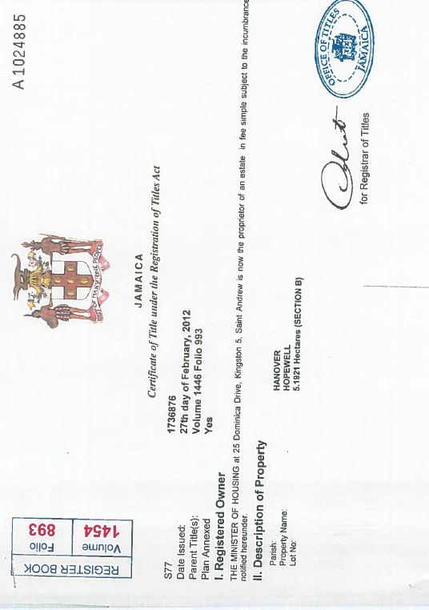
APPENDIX 1 – CERTIFICATES OF TITLE

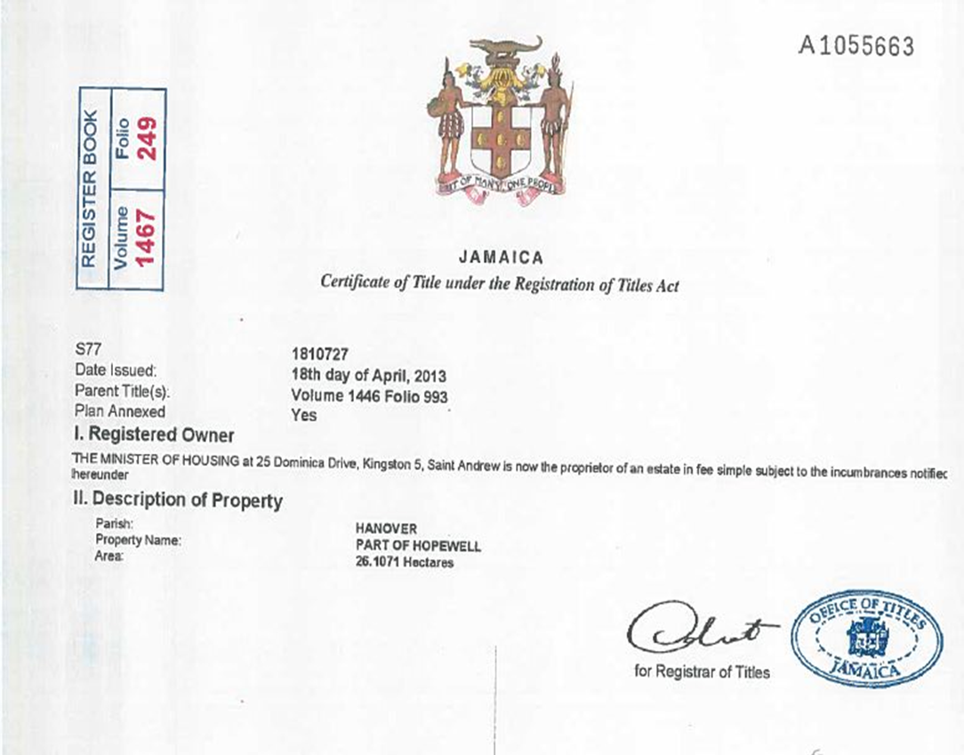

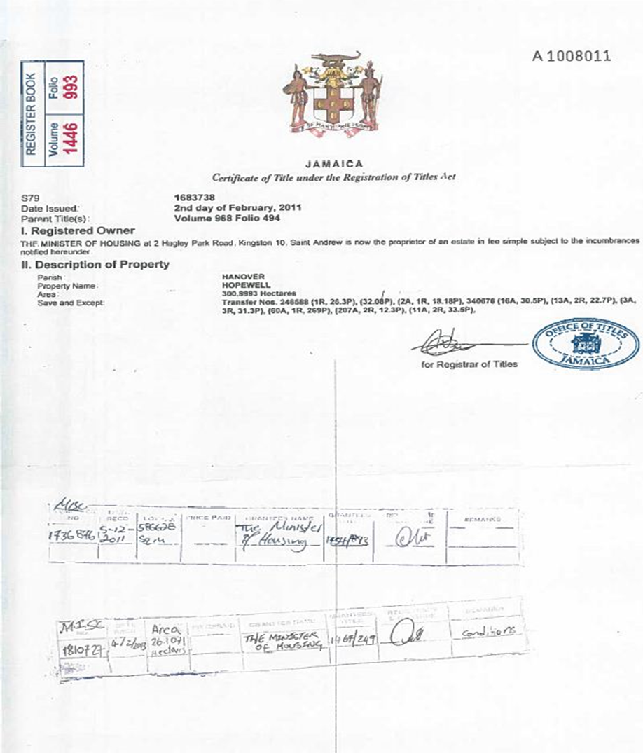

The amount of the Bond shall be denominated in the currency of the Procuring Entity’s country or the equivalent amount in a freely convertible currency.

